**JROTC MOVEMENT**

*Vashon High School JROTC Newsletter Edition 1, SY 17-18 Oct-Nov 2017*



Hello, I am Cadet Staff Sergeant Analeese Cruise. I am a LET-3 cadet participating in JROTC for the third consecutive year. I am responsible for publicizing our JROTC program information such as upcoming events, completed events and highlights. In addition, I maintain the JROTC bulletin board displaying school, local & national information; finally, I maintain the battalion scrap books. Cadets, please provide me with ideas or information for publication. I will publish monthly this newsletter.

JROTC Program Overview

JROTC serves as a character and leadership development program.

Vashon JROTC Program Vision

Vashon HS Army JROTC will become one of the top performing urban programs in which all students will become lifelong learners equipped with the appropriate skills and competencies to become successful citizens.

Special Points of Interest:

• Publisher Intro.

• JROTC Overview

• Vashon JROTC Program Vision

• JPA event

• Calendar

Overview--------Page 1

Publisher--Intro Page 1

JPA Event------- Page 2

Vittles with a Veteran

------------------on Page 3

STL City massing of the Colors-------------Page 4

General Info & Calendar—-----Page 5

**Torch**-Knowledge

**Wreath**-Knowledge passed from one generation to the next.

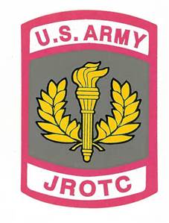

Vashon High School Earns Coveted Honor Unit with Distinction Award

November 7, 2017, Vashon JROTC completed the triennial JROTC Program of Accreditation (JPA). Vashon JROTC earned 96 points from a possible 100 after scoring by US Army representatives. The JPA began with an in-ranks inspection, color guard (C/CSM Grant, C/MSG Sutton, C/SFC Curry & C/SFC McFadden), and drill performances. Next, the cadet leadership team (C/MAJ Stidmon, C/CPT Harris, C/CPT Hodge, C/CPT Collins, C/CPT Moody) & C/1LT Nunley presented the Continuous Improvement Project (CIP) to Recruit, Train & Retain JROTC cadets. Immediately after the CIP briefing, C/MSG Sutton, C/SFC McFadden, C/SFC Perkins, C/SGT McKenzie & C/PVT Fortenberry briefed our JROTC Literacy Improvement Service Learning Project that earned a perfect score. The evaluators continued the review process by analyzing LET-1 through LET-4 cadet portfolios. Cadet Stidmon, Harris, Cruise, Archie, Taylor Marshall, Tabatha Marshall, Ndon, Standley & Small, you earned a perfect score for the portfolio interview session! The evaluator concluded the review by inspecting our organizational, supply and operations compliance with Cadet Command and US Army regulations. The result, cadets earned Honor Unit with Distinction (HUD), the highest award a JROTC unit can earn; with this honor, cadets wear a gold star attached to their JROTC uniform. Honor Unit with Distinction cadets have an advantage when applying for ROTC scholarships. Vashon High School principal or Senior Army Instructor can recommend and provide students a nomination letter to one of the military service academies (West Point, Naval Academy, Air Force Academy, Coast Guard Academy), if they are otherwise qualified. This is equivalent to a recommendation from a senator or congressional representative.

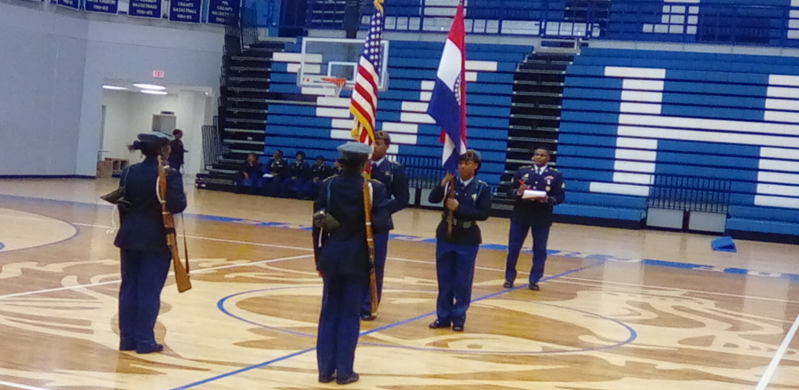

Vittles with a Veteran

Vashon JROTC celebrated Veterans Day in a very special way on Thursday, November 9, 2017 with a ceremony and vittles with a veteran. The keynote speaker was Brigadier General, US Army (Ret) Arnold Gordon-Bray. JROTC cadets Honored 15 United States military veterans from the local VFW, SLPS Safety Officer, and VHS staff and cadet relatives 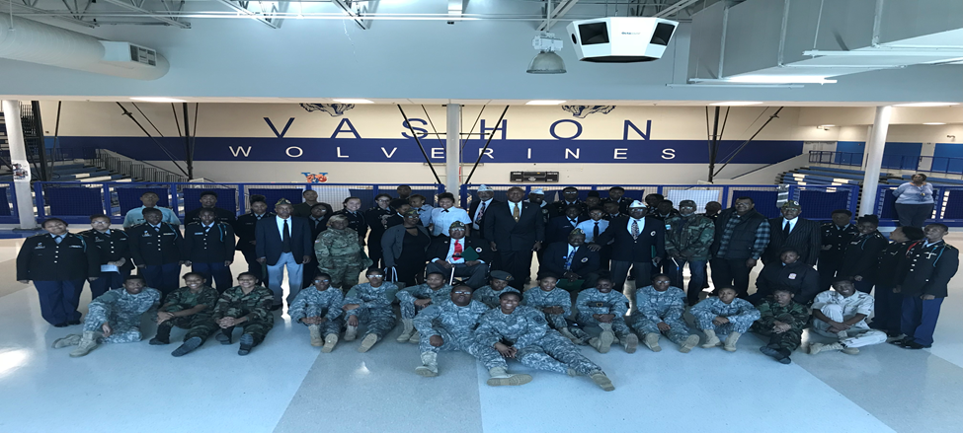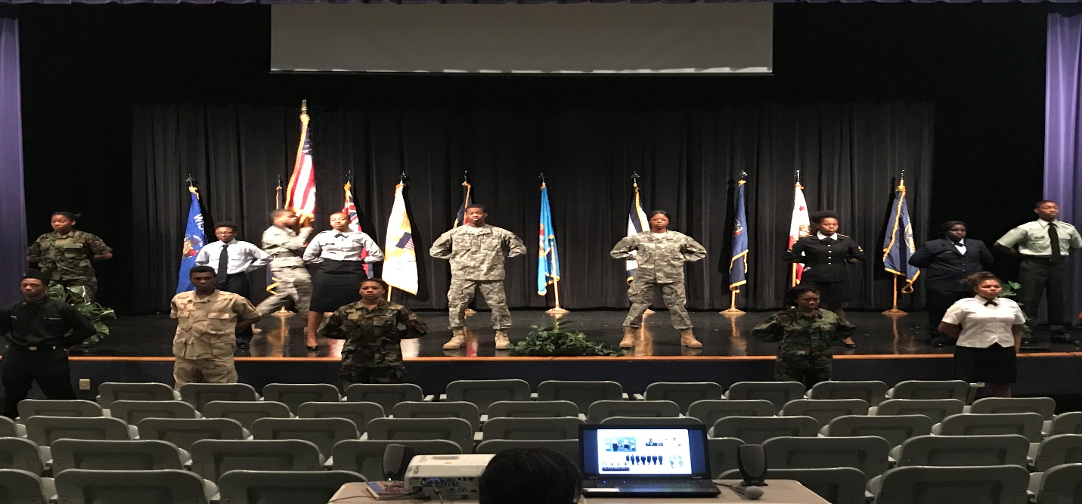

***(Picture(s) from this event)***

STL City Massing of the Colors

. November 11, 2017 Vashon AJROTC cadets carried US Army, Missouri and other state flags while participating in the annual Massing of the Colors and Veterans Day Parade that took place in Downtown STL, market & 14th streets. The events honored the flags and military soldiers who are serving or who previously served our country. Cadets, you were amazing!

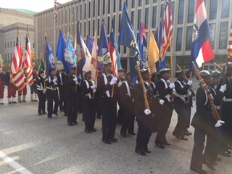

***Picture(s) from this event)***

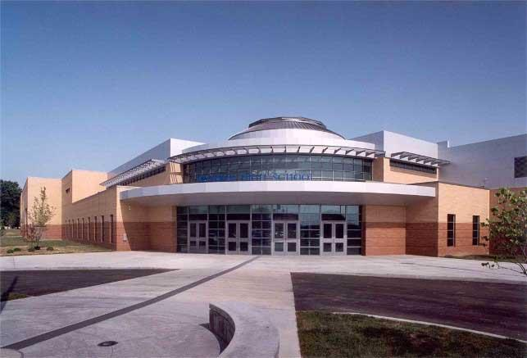

JROTC Upcoming Events

**November 2017**

28- Cadet Staff Meeting

30-Cadet of the Month Selection

**December 2017**

6-7- mentorship @ middle school/ uniform days

11-14 Essay Presentations

16- Visit Waynesville HS Drill Meet

18-20- 1st Semester Exams

21- Record keeping Day No Students

22-31 Winter Break

January 2018

3- Classes resume

Army JROTC Creed (Belief or Promise for Oneself)

The idea of a creed for JROTC originated in various high schools across the nation. During the many visits he made throughout the command in his first year as ROTC chief, Major General Lyle frequently encountered JROTC units that had created their own creed. It seemed to the Commanding General that this reflected a deep-seated need among cadets for such a statement purpose. Accordingly, he charged his high school directorate with the task of drafting a creed unique to all JROTC programs. Mr. Cal Foster took the lead in this project. Incorporating suggestions from the field, he produced the following creed:

**I am an Army Junior ROTC Cadet.**

**I will always conduct myself to bring credit to my family, country,**

**school and the Corps of Cadets. I am loyal and patriotic.**

**I am the future of the United States of America.**

**I do not lie, cheat or steal and will always be accountable for my actions and deeds.**

**I will always practice good citizenship and patriotism.**

**I will work hard to improve my mind and strengthen my body.**

**I will seek the mantle of leadership and stand prepared to uphold the Constitution and the American way of life.**

**May God grant me the strength to always live by this creed?**

**Vashon High School**

**3035 Cass Avenue**

**St. Louis, MO 63106**

**JROTC Instructors:**

**Sergeant Major Walter Wright, Senior Army Instructor**

**Sergeant First Class Lorenzo Harris, Army Instructor**